Application Design
ODS Mongo

Published date
Destruction date
Version
Author

This document is based on template Application Design,
version 5 (28/09/2018). Please check the link for the latest version.
https://intranet.rbsres01.net/Processes/Framework/deliverables/Pages/design/appdesign.aspx
Contents
1. Introduction 3
1.1. Application Design Purpose 3
2. Application Purpose 3
3. Application Context 3
4. Application Component Architecture 6
4.1. Patterns and Frameworks 6
4.2. Components, Interfaces & Pipelines 6
5. Application Security Design 7
6. Batch Run Details 8
6.1. Technical Platform 8
7. Other Technical Details 10

Introduction

Application Design Purpose
The purpose of the document is to describe the design components for end to end solution of ODS_MongoDB.
For the end to end solution, there are components developed on StreamSets platform to fetch data from CDB tables and write them to MongoDB.
This document provides the comprehensive details for the design and interfacing of all the components.

Application Purpose
The ODS_MongoDB project is to consume RAW data from the CDB Tables with the help of StreamSets platform and provisioning this data to different franchise teams/business areas by storing at MongoDB.
As part of this process, there are three layers which is controlled through StreamSets namely RAW_Layer, LS_Layer & TRN_Layer that links to Customer Database (CDB) and propagates the CIN associated transaction to MongoDB.
- RAW_Layer – The CDB data is considered as RAW data, consumed with the help of StreamSets platform and is published onto Kafka.
- LS_Layer – The RAW data at Kafka is consumed by LS_Layer’s StreamSets pipelines, processed further and is published back to Kafka for further processing.
- TRN_Layer – The data processed by LS_Layer is consumed from Kafka by TRN_Layer’s StreamSets pipeline, processed further and is written to MongoDB for further consumption by external applications.

Application Context
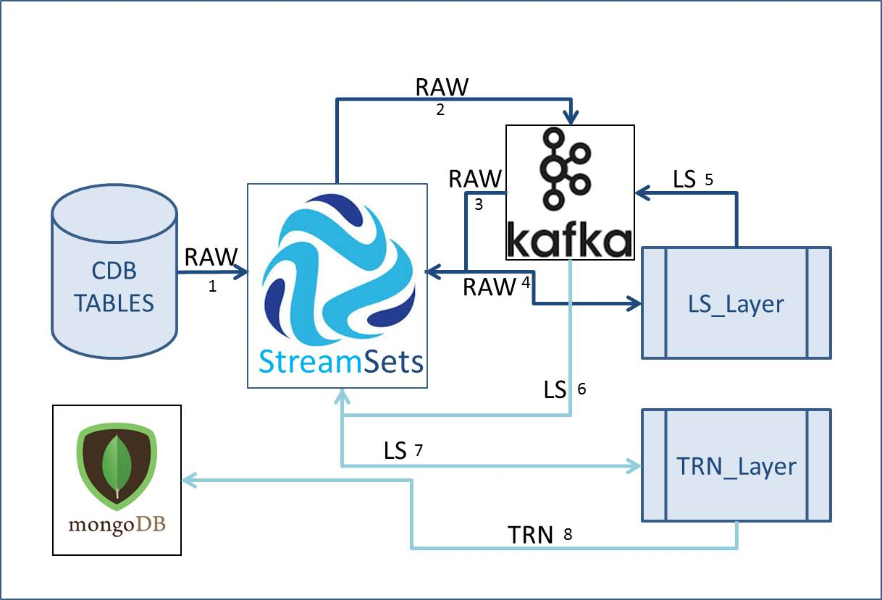
RAW Layer
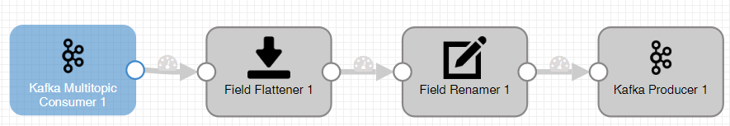

LS Layer
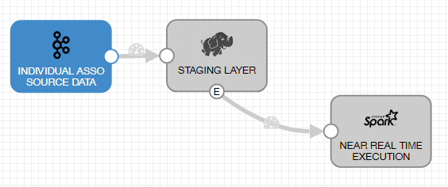

TRN Layer
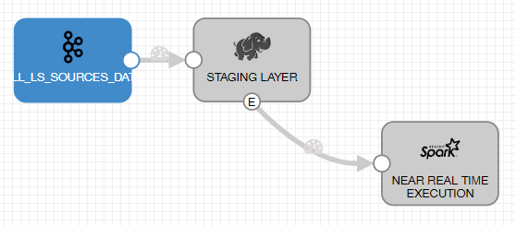
TRN Data flow
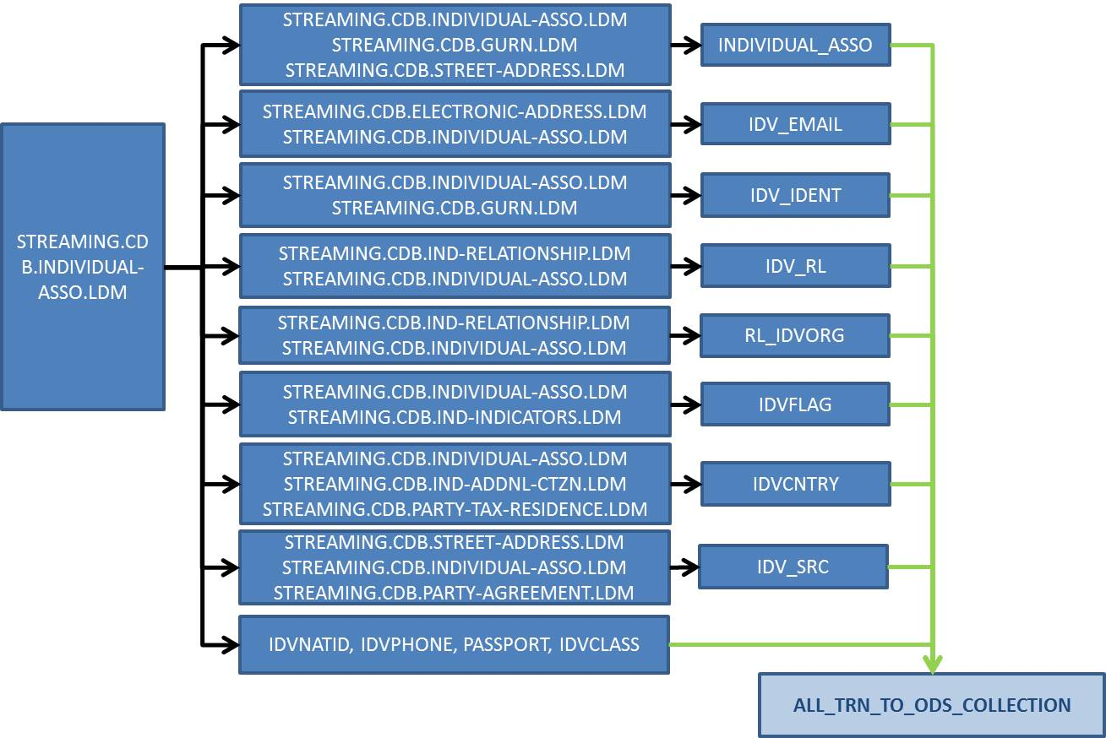

D&A Delivery
- All the pipelines from RAW_Layer would be fetching data from CDB Tables and writes it to Kafka.
- All the LS Layers & its EoD_Batch pipelines would be consuming data from Kafka as source and writes it after processes the data to Kafka while using Hadoop as temporary storage and PySpark script for processing data.
- The pipeline from TRN_Layer would fetch LS_layers data from Kafka and writes it to MongoDB after processing through it as a single Embedded document.
- Pipelines from VSL_Layer would be fetching Lookup data from Kafka and writes it to MongoDB for utilization at various layers.

Application Component Architecture

Patterns and Frameworks
Below image explains the data flow from various pipelines from RAW, LS & TRN layers sourced from CDB to MongoDB.
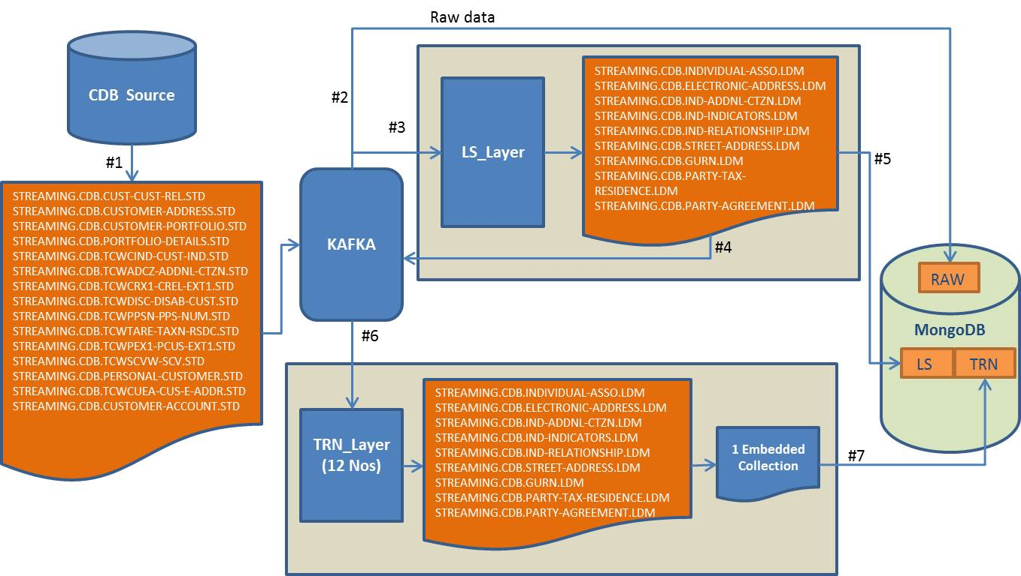

Components, Interfaces & Pipelines
Below are the various lists of RAW, LS & TRN layer pipelines from StreamSets.

RAW pipelines
S.No | Pipeline_Name
1 | ODS_RAW_CDB_CUST_CUST_REL
2 | ODS_RAW_CDB_CUSTOMER_ACCOUNT
3 | ODS_RAW_CDB_CUSTOMER_ADDRESS
4 | ODS_RAW_CDB_CUSTOMER_PORTFOLIO
5 | ODS_RAW_CDB_PERSONAL_CUSTOMER
6 | ODS_RAW_CDB_PORTFOLIO_DETAILS
7 | ODS_RAW_CDB_TCWADCZ_ADDNL_CTZN
8 | ODS_RAW_CDB_TCWCIND_CUST_IND
9 | ODS_RAW_CDB_TCWCRX1_CREL_EXT1
10 | ODS_RAW_CDB_TCWCUEA_CUS_E_ADDR
11 | ODS_RAW_CDB_TCWDISC_DISAB_CUST
12 | ODS_RAW_CDB_TCWPEX1_PCUS_EXT1
13 | ODS_RAW_CDB_TCWPPSN_PPS_NUM
14 | ODS_RAW_CDB_TCWSCVW_SCV
15 | ODS_RAW_CDB_TCWTARE_TAXN_RSDC
LS_Layer:
S.No | Pipeline_Name | Pipeline_Name (End of the day Batch)
1 | ODS_LS_CDB_IND_ADDNL_CTZN | ODS_LS_CDB_IND_ADDNL_CTZN_EoD_BATCH
2 | ODS_LS_CDB_INDIVIDUAL_ASSO | ODS_LS_CDB_INDIVIDUAL_ASSO_EoD_BATCH
3 | ODS_LS_CDB_IND_RELATIONSHIP | ODS_LS_CDB_IND_RELATIONSHIP_EoD_BATCH
4 | ODS_LS_CDB_DRIVER_CUST_RELATION | ODS_LS_CDB_DRIVER_CUST_RELATION_EoD_BATCH
5 | ODS_LS_CDB_GURN | ODS_LS_CDB_GURN_EoD_BATCH
6 | ODS_LS_CDB_PARTY_TAX_RESIDENCE | ODS_LS_CDB_PARTY_TAX_RESIDENCE_EoD_BATCH
7 | ODS_LS_CDB_IND_INDICATORS | ODS_LS_CDB_IND_INDICATORS_EoD_BATCH
8 | ODS_LS_CDB_PARTY_AGREEMENT | ODS_LS_CDB_PARTY_AGREEMENT_EoD_BATCH
9 | ODS_LS_CDB_STREET_ADDRESS | ODS_LS_CDB_STREET_ADDRESS_EoD_BATCH
10 | ODS_LS_CDB_DRIVER_CUSTOMER | ODS_LS_CDB_DRIVER_CUSTOMER_EoD_BATCH
11 | ODS_LS_CDB_ELECTRONIC_ADDRESS | ODS_LS_CDB_ELECTRONIC_ADDRESS_EoD_BATCH
VSL_Layer
S.No | Pipeline_Name
1
2
3
TRN_Layer:
S.No | Pipeline_Name
1 | ODS_TRN_ALL_IN_ONE_PROCESS

Application Security Design
Standard Hadoop access security & Kerberos security are in place. System User will be used for batch processing through StreamSets platform.

Batch Run Details
The RAW, LS, VSL & TRN layer batch would be scheduled to run twice per day.
The _EoD_Batch scripts from LS_Layer would be running once per day and at the end of the day.
The VSL_Layer would be scheduled to run once per day
All the layer pipelines also depends on the Kafka & Hadoop platform as temporary storage.

Technical Platform
Platforms
- Mainframe (CDB)
- KAFKA
- StreamSets
- Big Data Hadoop MM Cluster
- MongoDB
Technologies Used
- Py-Spark
- JSON
Folders
Folders
/opt/cloudera/sdc-custom/streamsets-datacollector-cdh_6_0-lib/lib/
/user/service-streaming/ods/stg_dir/all_ls_data/
Users and Groups
User/ Group | Group Names (per naming standard)
System User
Application Support Group

Sentry Roles
Sentry Roles | Group | Permission
Database
Database Name | Location | Storage

IH Configuration
Refer

Other Technical Details
< Include any other technical details about the application such as:
• Data management approach: owner of data, location of master copies, control of replicated data (ensuring GDPR compliance is maintained across all master and copy data stores, as outlined within Section 5)
• Job Control Scripts
• Compilation details >>
[ Remove the square brackets and overtype with project content; when finished, delete any guidance boxes ]
Appendix A: Detailed response to the Technology Operational Principles
< As compliance with the Technology Operational Principles is mandatory it is highly recommended that this section be completed. You can signify compliance in a number of ways but by consolidating the responses here it will assist in expediting the Design and Fit for Production Reviews. All that may be necessary is to provide a cross-reference to a point within this document or brief comment or a reference to another document. In cases where it is not reasonable to be able to state compliance at this point then give some idea of what plans there are to cover the principle. The Technology Operational Principles are found at:
https://intranet.rbsres01.net/Processes/TechnologyLibrary/Pages/Technical-Standards.aspx
These are the principles against which the design will be assessed by the relevant technical expert. This is done through the Operational Readiness Passport. This is found at:
http://www.manufacturing.rbsgrp.net/gtchange/change_assurance/change_assurance_overview.asp
The following table is a suggested response format: >
Operational Principle | Operational Principle No. | Response or Reference to Relevant Document
[ Remove the square brackets and overtype with project content; when finished, delete any guidance boxes ]
Document details
Filename & location – xxxx\xxxx
Document references – xxxx
Date | Version | Details
Circulation and reviews
Name | Reason
Sign-offs
Name | Role | Acceptance signature/Date

